Project Demo

“Implementing infoprocess System Call”

The Department of Computer Science
Arkansas State University
Jonesboro, Arkansas, United States

Class: Operating System Design
Dr. Hai Jiang
Semester: Fall 2018

Submitted by
Ahmad A. Banisaeed

Abstract
A process is the instance of a computer program that is being executed. It contains the program code and its activity. While a computer program is a passive collection of instructions, a process is the actual execution of those instructions. Several processes may be associated with the same program; for example, running several instances of the same program often results in more than one process being executed.
Therefore, in my project, I implemented processinfo system call, which goes through each running process in the system using for_each_process macro which itertes through the list of all the processes. These process info will be printed out in the dmesg log.
The process informations that the system call retrieves are process name, process PID number, process state, process priority, process RT_priority, process static priority, process normal priority, also the parent process name, and parent process PID.
I tried to implement the system call on kernel 4.18.6, but the kernel crashed. Therefore, I installed a new version of linux kernel vrsion 4.19.2. (Figure 1)

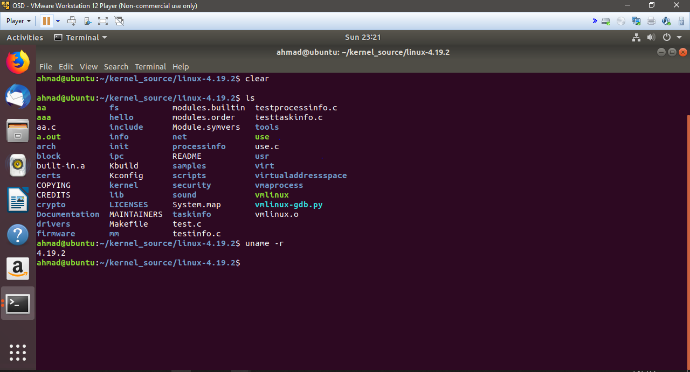
Figure 1: Kernel 4.19.2
Implementation
To implement the system call, I followed the mentioned below steps:
- Create a directory named processinfo in the linux-4.19.2 directory
mkdir processinfo

- Move to the newly created directory
cd processinfo

- create processinfo.c using vi editor

vi processinfo.c
and write the following code:

#include <linux/kernel.h>
#include <linux/init.h>
#include <linux/sched.h>
#include <linux/syscalls.h>
#include <linux/file.h>
#include <linux/fs.h>
#include <linux/fcntl.h>
#include <asm/uaccess.h>
#include <uapi/asm-generic/errno-base.h>

asmlinkage long sys_processinfo(void) {

struct task_struct *proces;

for_each_process(proces)
{
// Process Name
printk("Process: %s\n", proces->comm);

// Process PID
printk("PID Number: %ld\n", (long)proces->pid);

// Process State
printk("Process State: %ld\n", (long)proces->state);

// Process Priority
printk("Priority: %ld\n", (long)proces->prio);

// Process RT_Priority
printk("RT_Priority: %ld\n", (long)proces->rt_priority);

// Process Static Priority
printk("Static Priority: %ld\n", (long)proces->static_prio);

// Process Normal Priority
printk("Normal Priority: %ld\n", (long)proces->normal_prio);

if(proces->parent) {
// Parent Process Name
printk("Parent process: %s\n", proces->parent->comm);

// Parent Process PID
printk("PID_Number: %ld \n\n", (long)task_pid_nr(proces->parent));
}

printk("\n\n");
}

printk("============================\n");
printk("\n\nAuthor: Ahmad Banisaeed.\n");
printk("\n***System Call processinfo***\n");
printk("============================\n");

return 0;
}

- Create Makefile within the same directory
vi Makefile

and write and the following:

obj-y:= processinfo.o
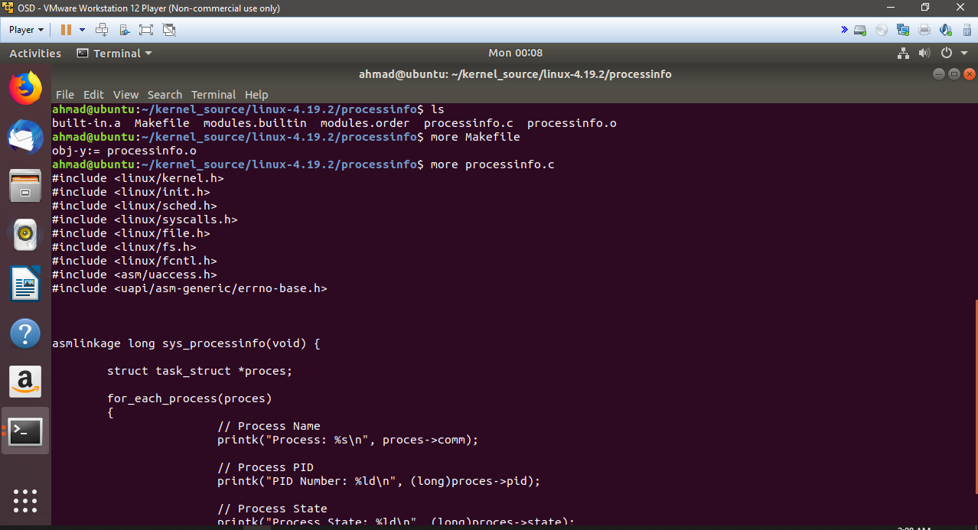

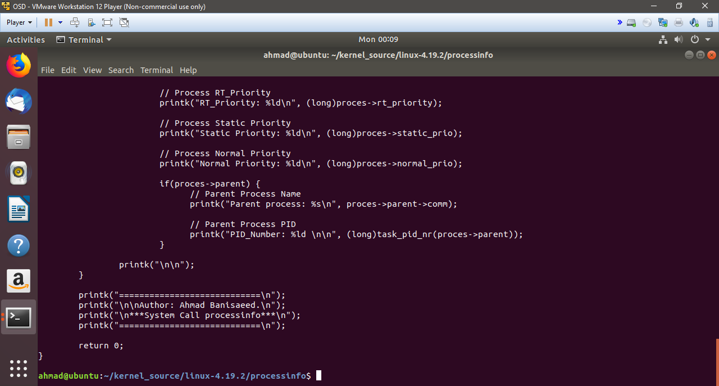
- Now, go back to the parent directory, (linux-4.19.2), using
cd ..
and update the Makefile file within this directory, using
vi Makefile

find the line:
core-y += kernel/ certs/ mm/ fs/ ipc/ security/ crypto/ block/ hello/ virtualaddressspace/ vmaprocess/ info/ taskinfo/

and add at the end of the line:
processinfo/

the line will become like this:
core-y += kernel/ certs/ mm/ fs/ ipc/ security/ crypto/ block/ hello/ virtualaddressspace/ vmaprocess/ info/ taskinfo/ processinfo/

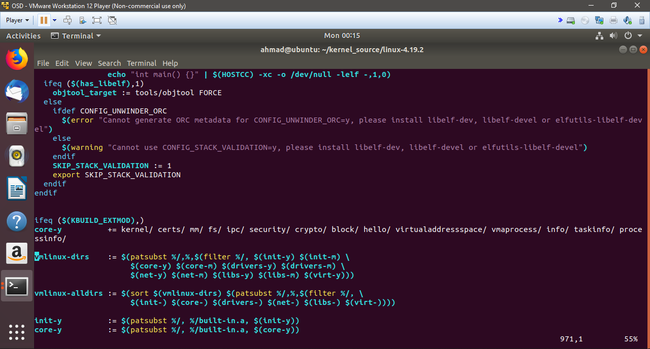
Save, and exit.
- Now, we need to add our system call in the syscall_64_tbl table, write the command:

vi arch/x86/entry/syscalls/syscall_64.tbl

keep going down and add your system call before you get to line starts with 512.

340 64 processinfo sys_processinfo

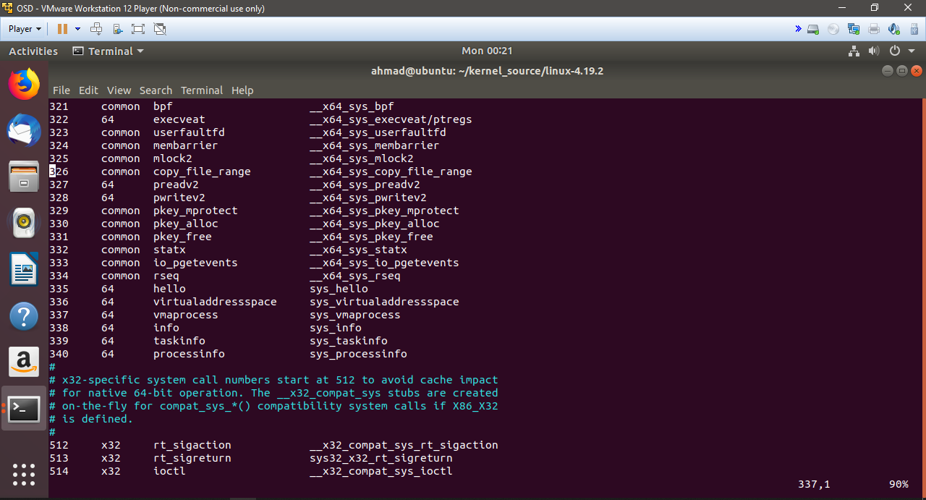

Save and exit.

- Now, we need to update syscalls.h file, using this command:

vi linux/kernel/syscalls.h

and add just right before #endif, your system call

asmlinkage long sys_processinfo(void);

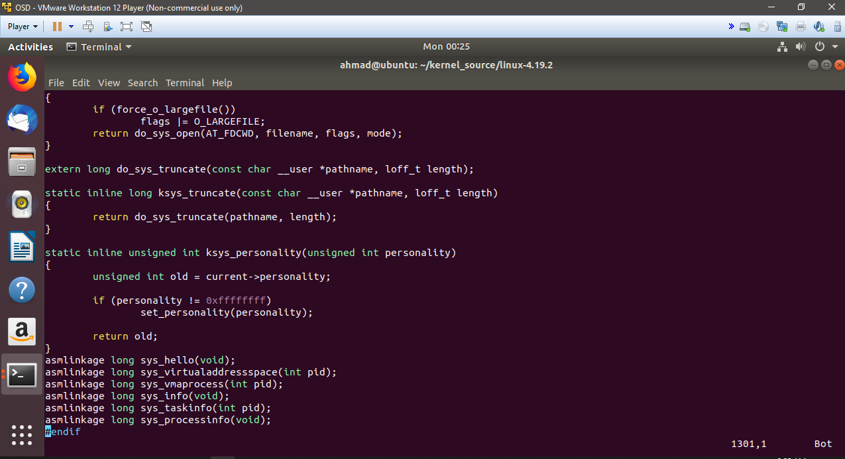

save and exit.
After that, you will go back to this screen, withing linux-4.19.2 directory.

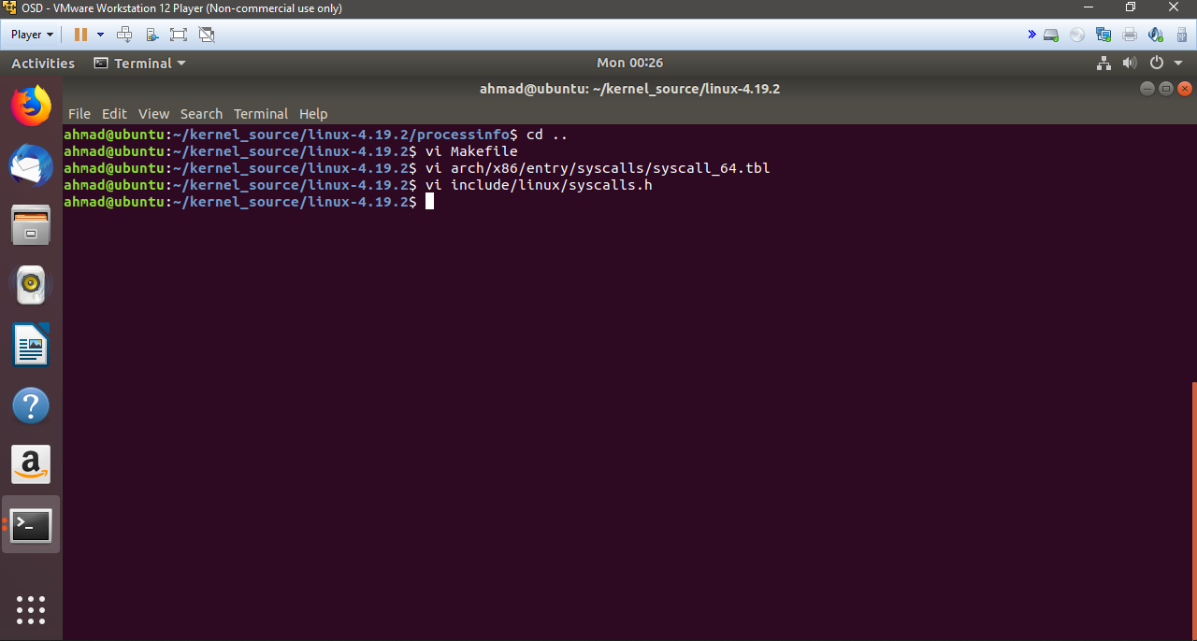

- Now, it’s the last step, which is to compile and build the kernel.
Using the following commands:

sudo make menuconfig

sudo make -j4

sudo make -j4 modules_install

sudo make -j4 install

- After finishing building and cmpiling the kernel, reboot.

- Testing the new system call:
To test the new system call, I added the following program, called it testprocessinfo.c

#include <stdio.h>
#include <linux/kernel.h>
#include <sys/syscall.h>
#include <unistd.h>
int main()
{
printf("Invoking 'processinfo' system call\n\n");

long int ret_status = syscall(340); // 340 is the syscall number

if(ret_status == 0)
printf("System call 'processinfo' executed correctly.\n\nUse dmesg to check processinfo\n\n");

else
printf("System call 'processinfo' did not execute as expected\n\n");

return 0;
}

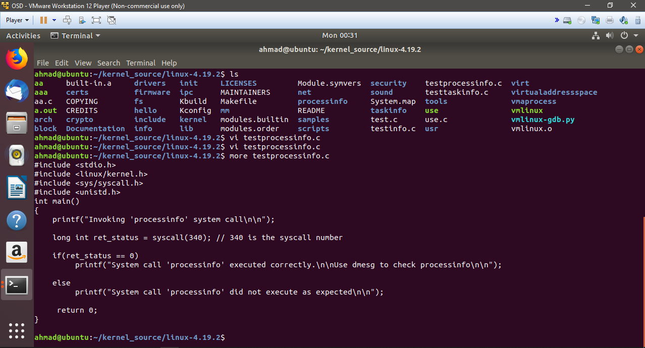

- Compile the program, and see the results:
gcc testprocessinfo.c

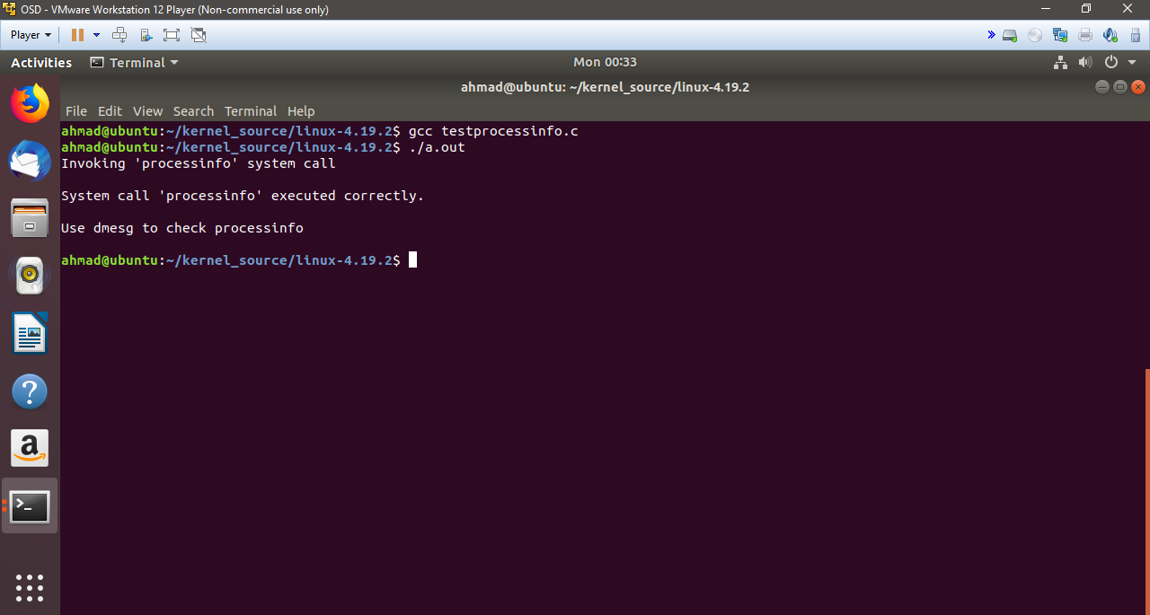

- Check dmesg log, and see the processes info, using the command:
dmesg

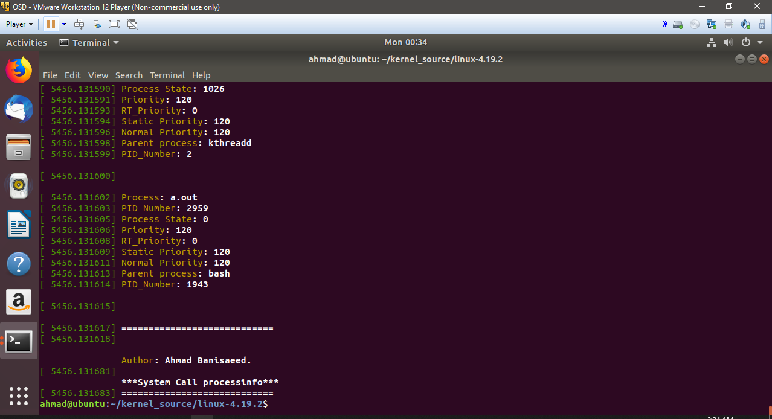

Conclusion
I did try to implement system call many times, first I started out with hello system call, to get the feeling of how to implement a system call. After that, I tried to do the process info system call, I had some errors at the first time. My kernel 4.18.6 crashed. After that, I did installed a new kernel 4.19.2, and implemented the system call, which works as planned.

